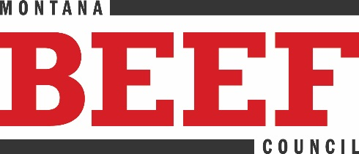
Montana Beef Council
2795 Enterprise Ave., Ste. 4
PO Box 80865
Billings, MT 59108
(406) 656-3336
www.montanabeefcouncil.org

NEWS RELEASE CONTACT INFO
February 12, 2021 Chaley Harney, Executive Director
FOR IMMEDIATE RELEASE (406) 855-2857
chaley@montanabeefcouncil.org

Montana Loves Beef Campaign
New beef promotion boasts praise for Montana ranchers by keeping beef top of mind.

BILLINGS, MONTANA – It is no secret that cattle outnumber people in Montana, and even in the most urban areas of the state, it is a short drive to see cattle grazing and appreciate the largest agriculture economy in Montana.
To show their appreciation for Montana’s ranchers and remind consumers that beef is a top protein, Montana Beef Council (MBC) is launching a new branded campaign called “Montana Loves Beef.” It is no coincidence that the campaign kicks off right before Valentine’s Day and in the middle of heart health month.
“Enjoying beef in a heart-healthy lifestyle is easier than one might think with a number of beefy recipes that are certified by the American Heart Association and can be found at BeefItsWhatsForDinner.com,” said Chaley Harney, Montana Beef Council Executive Director. “We also have a wealth of beef and heart health research for beef-loving fans and health professional to ensure beef stays on the menu.”
Throughout the month-long campaign, Montana Beef Council will execute a multimedia campaign to showcase beef through television, radio, digital and print. A catchy jingle has also been created to keep beef top of mind and beefy contest giveaways will be available through Montana Beef Council’s Facebook and Instagram pages.
The MBC Board of Directors is comprised of twelve volunteer Montana leaders representing nearly all segments of the beef supply chain. Meet the full board of directors at the next meeting to be held on May 21, 2021. Learn more about the directors and read the full marketing plan online at MontanaBeefCouncil.org.
#####

Montana Beef Council is organized to protect and increase demand for beef and beef products through state, national and international consumer marketing programs thereby enhancing profit opportunities for Montana beef producers.

