NEWS RELEASE CONTACT INFO
April 5, 2023 Chaley Harney, Executive Director
FOR IMMEDIATE RELEASE (406) 656-3336
chaley@montanabeefcouncil.org

Montana Beef Council Staff and Directors Attend Educational Event

BILLINGS, MONTANA – The Montana Beef Council joined 25 other state beef councils (SBCs) to learn about the Beef Checkoff and share ideas during an orientation hosted by the Federation of State Beef Councils. Justin Iverson of Potomac, Charlie Hollenbeck of Forsyth and Debbie Andersen of Livingston, directors on the Montana Beef Council board, and Executive Director Chaley Harney, participated in the SBC Staff and Director Orientation held March 23-24, in Denver.

New SBC staff members and directors came together to learn about their roles and responsibilities as stewards of the Beef Checkoff. Attendees learned about the Beef Act & Order, Checkoff history, fiduciary responsibility and Checkoff payment compliance.

Staff from the National Cattlemen’s Beef Association (NCBA) also provided recent campaign results of Checkoff-funded programs and discussed the latest research about “Today’s Beef Consumer.” The event served as a way for SBCs to network with one another, meet NCBA staff and learn about available Federation resources.

“A highlight to me was the hard work that is going into researching the beef consumption trend,” said Charlie Hollenbeck, owner of Cowboy Meats in Forsyth. “As a local meat processor, we can help fill that demand as we see current herd numbers still shrinking going into the summer. I see great optimism going into the summer grilling season where we can continue to reach consumers with the great story of cattle and the great value of beef.”

The vision of the Federation of State Beef Councils is to build beef demand by inspiring, unifying and supporting an effective and coordinated state and national Checkoff partnership. The Federation, which is celebrating its 60th anniversary this year, represents the 43 Qualified State Beef Councils and is housed by NCBA, a contractor to the Beef Checkoff.

“I enjoy seeing state beef council staff and directors from across the country gather together to learn, network and share ideas,” said Clark Price, Federation of State Beef Councils chair. “Events like this help strengthen the Federation’s state and national partnership.”

For more information about how the Montana Beef Council is driving the demand for beef, visit MontanaBeefCouncil.org.

About the Montana Beef Council
The Montana Beef Council was created in 1954 by cattlemen as a marketing organization for the Montana Beef industry. It is one of 43 state beef councils. A 12-member board of directors oversees the Montana Beef Council. In accordance with council bylaws members are appointed or elected by membership organizations as follows: Montana Stockgrowers, Montana Cattlemen's Association, Montana CattleWomen, Livestock Auction Markets, Cattle Feeders, Meat Packer/Processor, Farm Bureau, Farmers Union, Retailer, Dairymen, and Montana Angus Association.

About the Federation of State Beef Councils
The Federation of State Beef Councils is housed by the National Cattlemen’s Beef Association (NCBA), which is a contractor to the Beef Checkoff Program. The program is administered by the Cattlemen’s Beef Board, with oversight provided by the U.S. Department of Agriculture. The Beef Checkoff Program was established as part of the 1985 Farm Bill. The Checkoff assesses $1 per head on the sale of live domestic and imported cattle, in addition to a comparable assessment on imported beef and beef products. States retain up to 50 cents of the dollar and forward the other 50 cents per head to the Cattlemen’s Beef Promotion and Research Board.

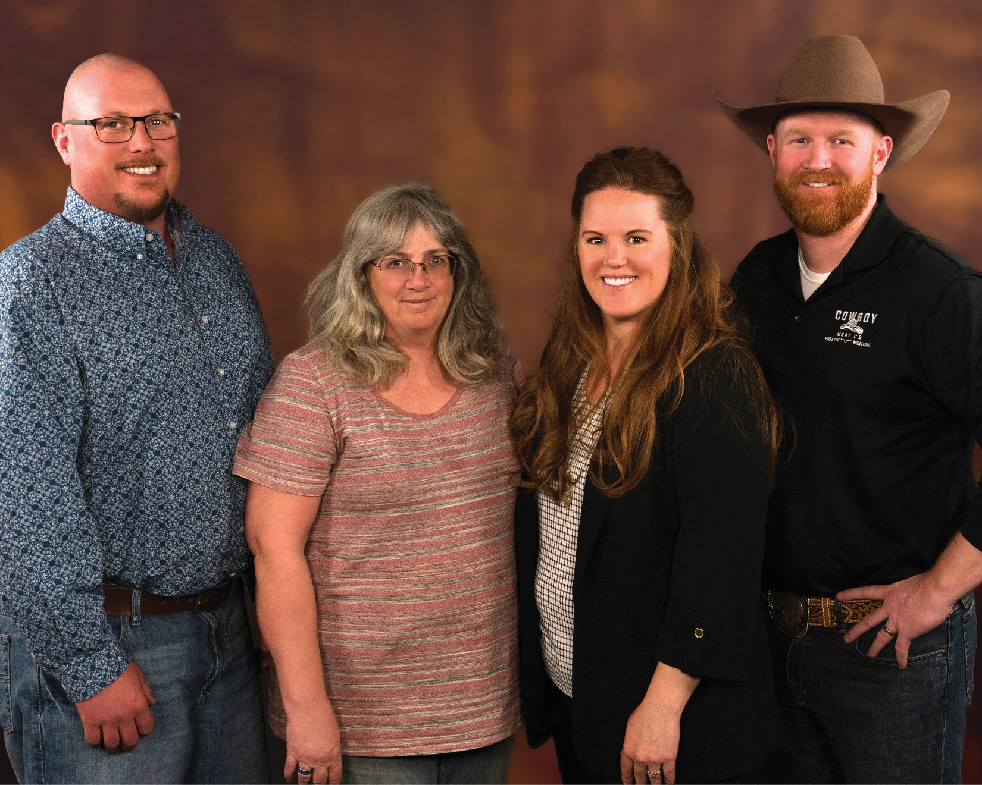
Pictured left to right: Justin Iverson, Debbie Andersen, Chaley Harney, Charlie Hollenbeck.

